Installation Procedure Microsoft Dynamics Business Central Role Tailored Client

- Download the Microsoft Dynamics NAV BC Product DVD from the following location:
Carya File Server (External)
https://files.carya.cloud/NAV%20Client/Business%20Central%20365/

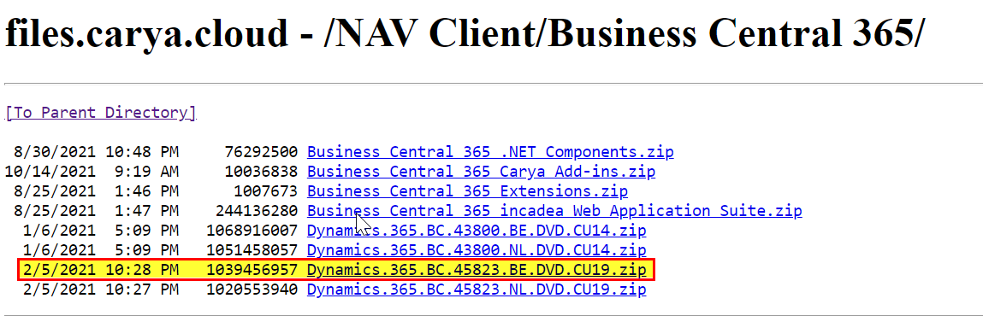
- Extract the downloaded Zip file to folder C:\Temp\

- Double click setup.exe in the root folder:
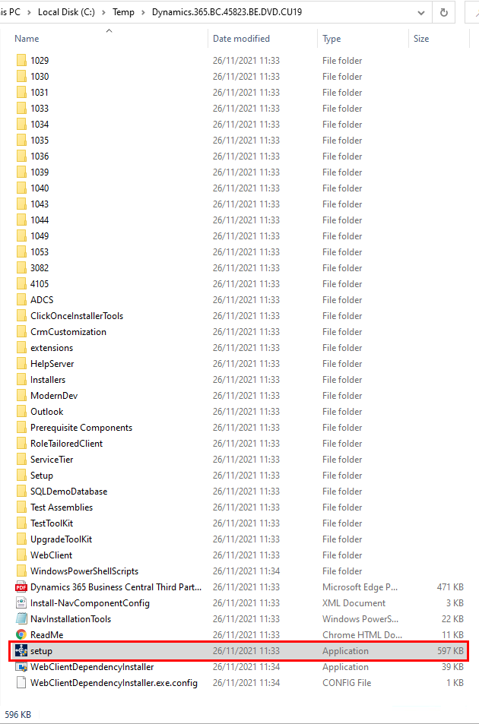

- Click the “Next” button:
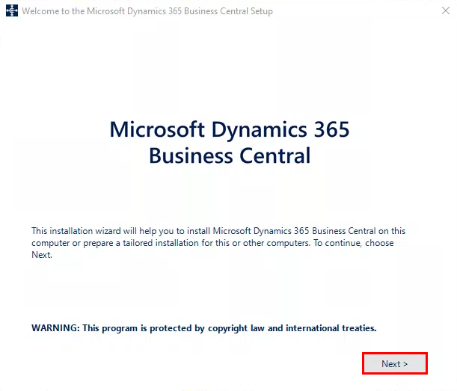
- Click the “I accept” button:
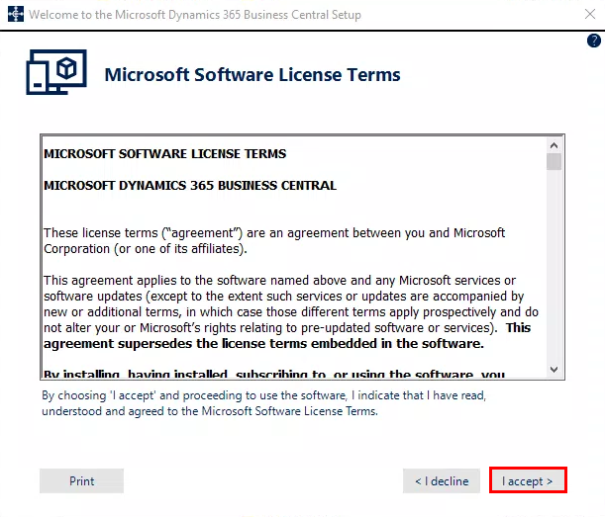
- Click “Advanced Installation options”:
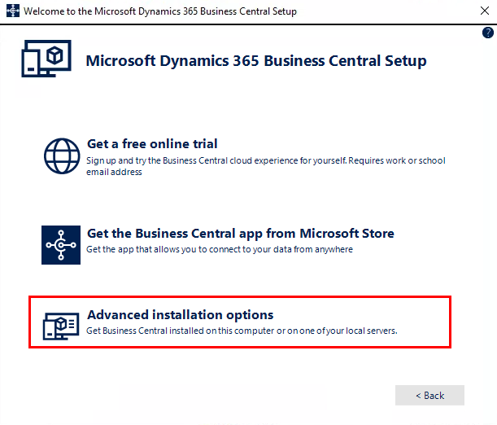
- Click “Choose an installation option”:
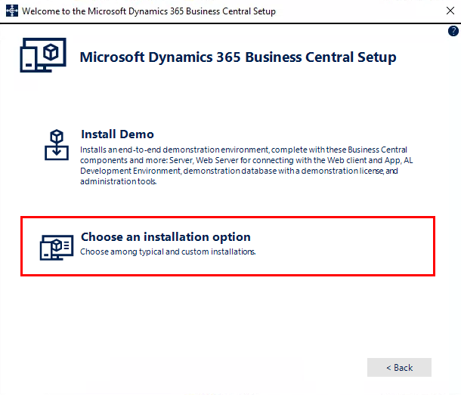

- Choose option “Customize” under Client:
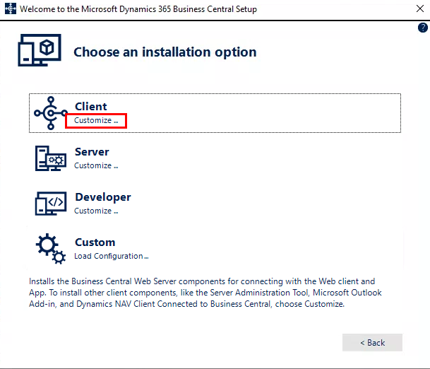
- Allow “Microsoft Excel Add-in” to be installed. This enables the CTRL + E in Microsoft Dynamics BC

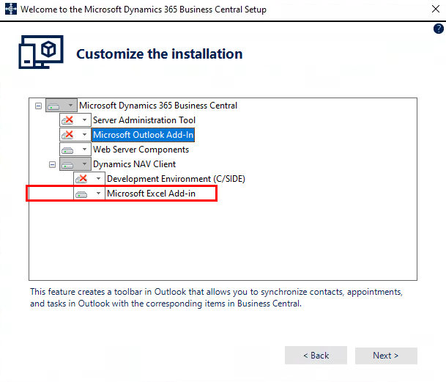

- In the Specify parameters screen, only change parameter Server Computer Name from localhost to the name of the NST Server (e.g. CARYANST030009) and click the Apply button. Do not change any of the other parameters:
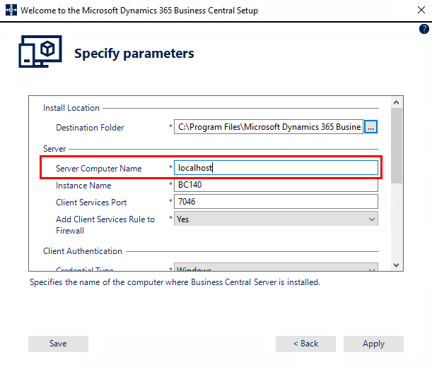
- The Microsoft Dynamics BC RoleTailored Client is now installing. The following screen appears. Wait until the installation is finished:
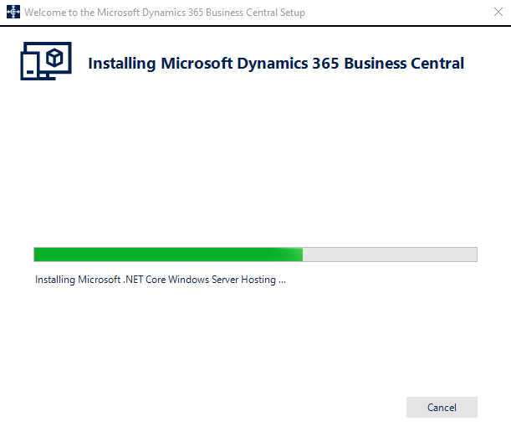
- When the installation has completed successfully, the following screen is shown:

When Warnings or Errors are listed, the installation has NOT completed successfully and the installation is rolled-back automatically. In that case, first fix the listed problem and start the installation procedure again.
- Download the Business Central 365 .NET Components for incadea.dms from the following location:

Carya File Server:
https://files.carya.cloud/NAV%20Client/Business%20Central%20365/

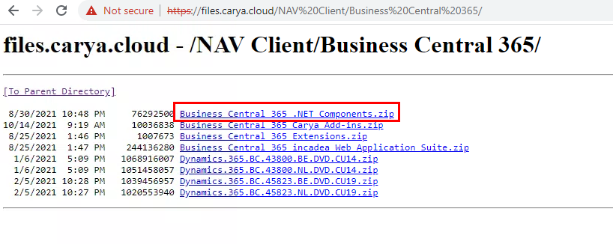
Extract the downloaded ZIP file to folder C:\Temp

Double click on both .msi files as shown below to install them
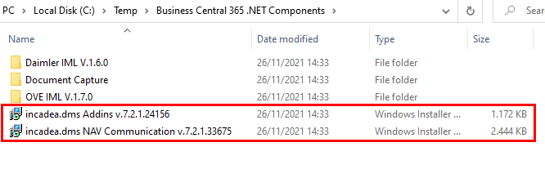
.NET Components to be installed on EACH client/computer:

- Add-ins
- NAV Communication

For customers using the new Web Service Planner NO additional components need to be installed (only Add-ins and NAV Communication)

For Daimler customers: make sure that Daimler GO.msi is installed (visible in programs & features) if not double click on the .msi file as shown below:
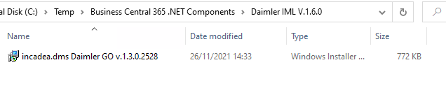
The new Web Service Planner is ONLY accessible through Google Chrome. The Web Service Planner does NOT support Internet Explorer/Microsoft Edge.

- Download the Carya add-ins for incadea dms from the following location:
Carya File Server
https://files.carya.cloud/NAV%20Client/Business%20Central%20365/
Extract the downloaded ZIP file to folder C:\Program Files (x86)\Microsoft Dynamics NAV\100\RoleTailored Client\Add-ins\
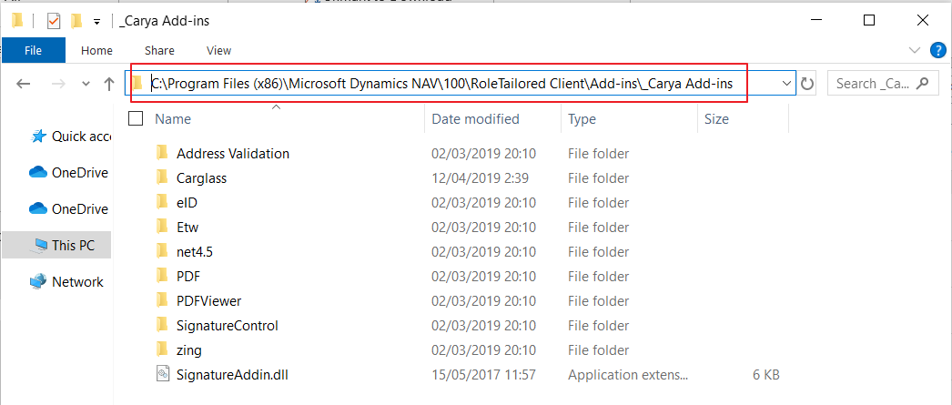
When installed make sure that every .dll file is unblocked in each directory of the _Carya Add-ins folder. Possible to verify when displaying the properties of the .dll file.
If files are blocked as shown below, each .dll file needs to be unblocked by checking the unblock flag in the properties. Confirm by pressing Apply - OK

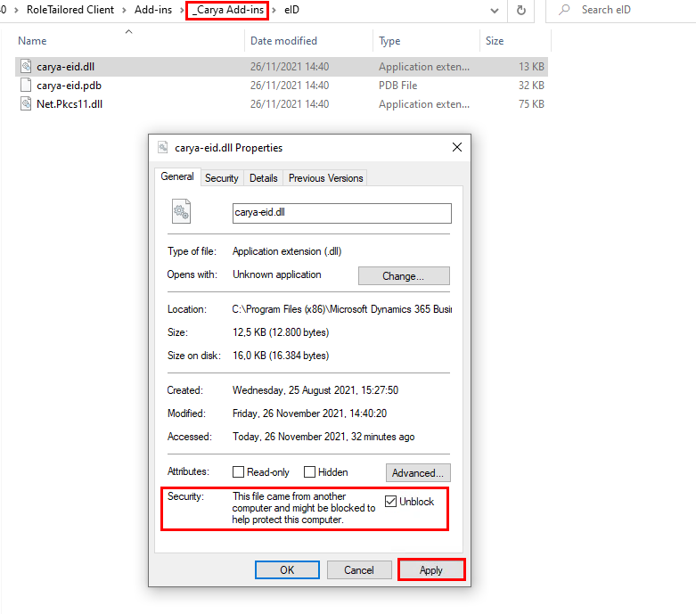

Installation of BC with its .NET Components and _Carya Add-ins is now successful.

